Lab 7: Forecasting - Analysis

Background:
For questions 2, 3, 4, 5, and 6 you should be going to the NCAR website below and following the directions to get real-time data. Don’t use the National Weather Service.

NCAR: http://weather.rap.ucar.edu/satellite.
Follow the directions below once you get to the site:
  - Choose your satellite type (visible, IR, water vapor)
  - Choose your loop duration in the dropdown to 12 hours (if you want a single image then just click single image)
  - Change the button located above the map to “large size”
  - Click on “contiguous US” on the map

Question 1:
Use the Visible Image 1 I have provided here rather than the current loop. For the questions, be specific and tell me the STATES.

Visible Image 1:
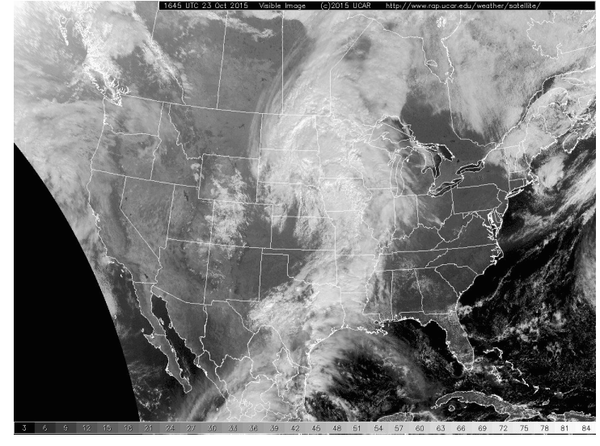

Question 2:
Use the NCAR website to get 12 hour loops to help you (directions at beginnong of document). THINK! What is the major downside looking at visible light at different times? (slide 4)

Question 3:
Using the NCAR website look at visible, IR , and water vapor (high) imagery. Which one looks most clear (highest resolution) to you. It may be helpful to pull up the links in a few tabs and flip back and fourth to see which is clearer.

Question 4:
Use NCAR website. Under daytime conditions there are two types of imagery that work well together. For part b, think about what you wrote for question 2.

Question 5:
You are running a 12 hour loop of the water vapor (low level) imagery on the NCAR website. Make sure you are telling me where there is a lot of moisture, not just moisture in general. Tell me this in terms of general regions/states (i.e., around the west coast, Southwest, near Mexico, etc.). The question reads funny so just think of it as “where is there a lot of moisture?”

Question 6:
Use the same loop on the NCAR website as in question 5. Try to find each of the three features described in question 6 and give me a geographic location. Some features may not be present.
- It is helpful to adjust the speed at the top of the page. I find it easiest to see cyclonic (counter clockwise motion) when the loop is speed up a lot.

Question 7:
If you are stuck on this problem I recommend re-reading the background.

SKIP QUESTIONS 8 AND 9.

Question 10:
Use Infrared Image 1 and Visible Image 2 below (not the visible image you used on question 1). They were taken at the same time. Tell me what types of clouds you see in: 1) southeastern Texas, and 2) off the southeastern coast of Texas in the Gulf of Mexico. Don’t choose your own locations. Remember to identify cloud type and what effect that cloud might have in terms of temperature and precipitation. If you are stuck, reread the bottom of page 43 and top of 44.

Infrared Image 1:
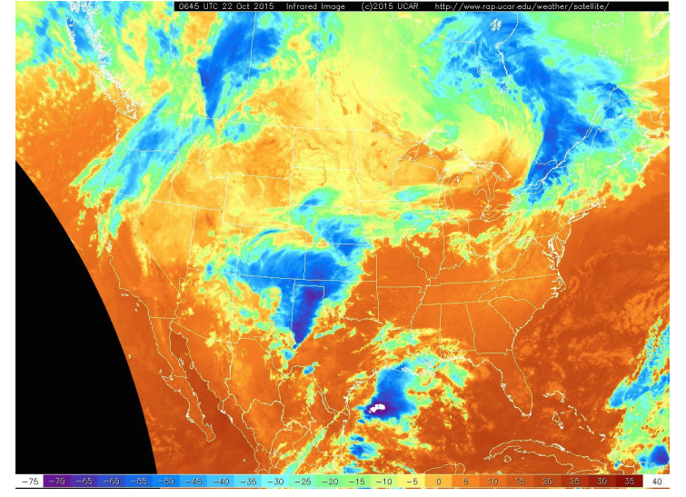

Visible Image 2:
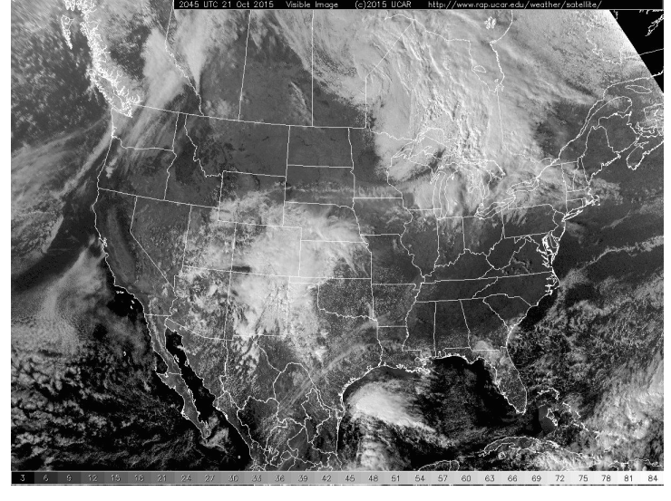

Questions 11:
Use the printed map I have given out. It is an upperlevel air map and you will be finding the jet stream. Write on the margins of the map what is the maximum and minimum wind speed on the entire map. Refer to the powerpoint to see how barbs and flags relate to knots. Make sure to include units.

Question 12:
Draw the jetstream by following through areas of fast wind. The jets stream should follow a wave like pattern.

Question 13:
Use the provided map of the jet stream below, and try to correlate it with the Surface Temperatures figure below in order to figure out where the division of warm and cold air masses is. The jet stream typically splits the cold air north and the warm air south which we can see when we look at how the surface temperatures relate to upperlevel winds. As the jet stream moves, warm or cold air is transported and so the location of the troughs and ridges determine which places are warmer than normal or colder than normal (slide 10). Using the maps below tell me if the following places are warmer than normal or colder than normal:
- Kansas
- West Virginia

Upper Air Map (300mb Winds):
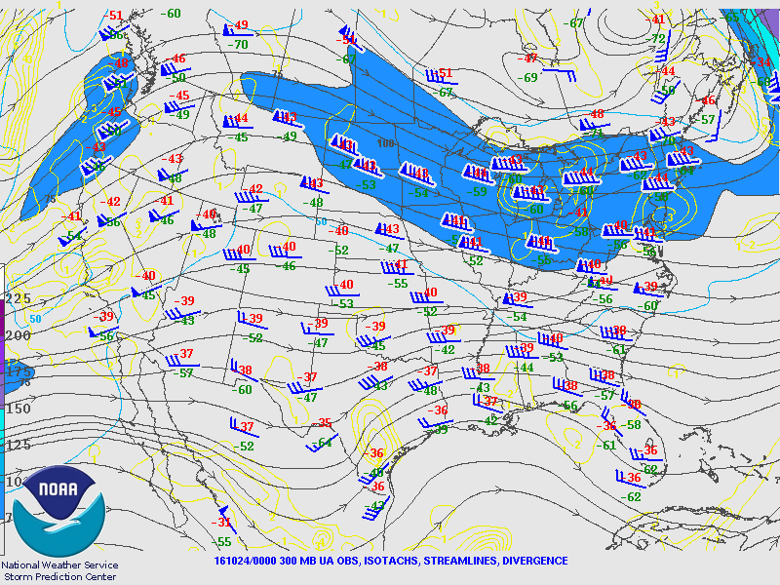

Current Surface Temperatures:
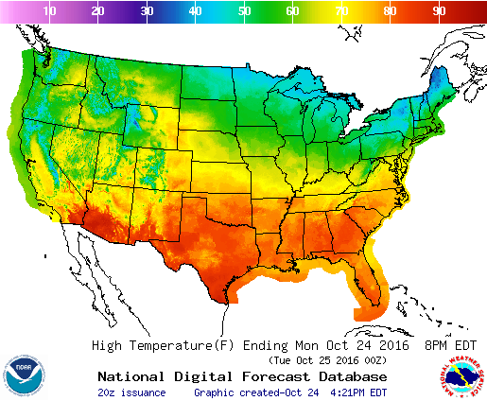

Question 14:
If the jet stream is fast moving air, which imagery will let us she the transportation of air.

Question 15:
You are using the upper air map at the bottom of pg 48 (Figure 5). Do this exercise on the jet streak just south of the U.S.. Circle the two locations coresponding to that jet where air will have vertical motion (upper level divergence). See slide 12. Now star which of the two locations will have the strongest vertical motion (Slide 13). How well does this account for the rain we see in figure 6? What other factors account for precipitation?

SKIP QUESTIONS 16 AND 17.

