Lab 6: Atmospheric Instability

Background:
You should register at meted.ucar.edu for tutorials on reading the more complex versions of skew-T diagrams. It is free and takes only a few seconds to sign up. This will help you immensely because this lab is very difficult. URL for skew-T lesson is: http://www.meted.ucar.edu/mesoprim/skewt/

Figure1:
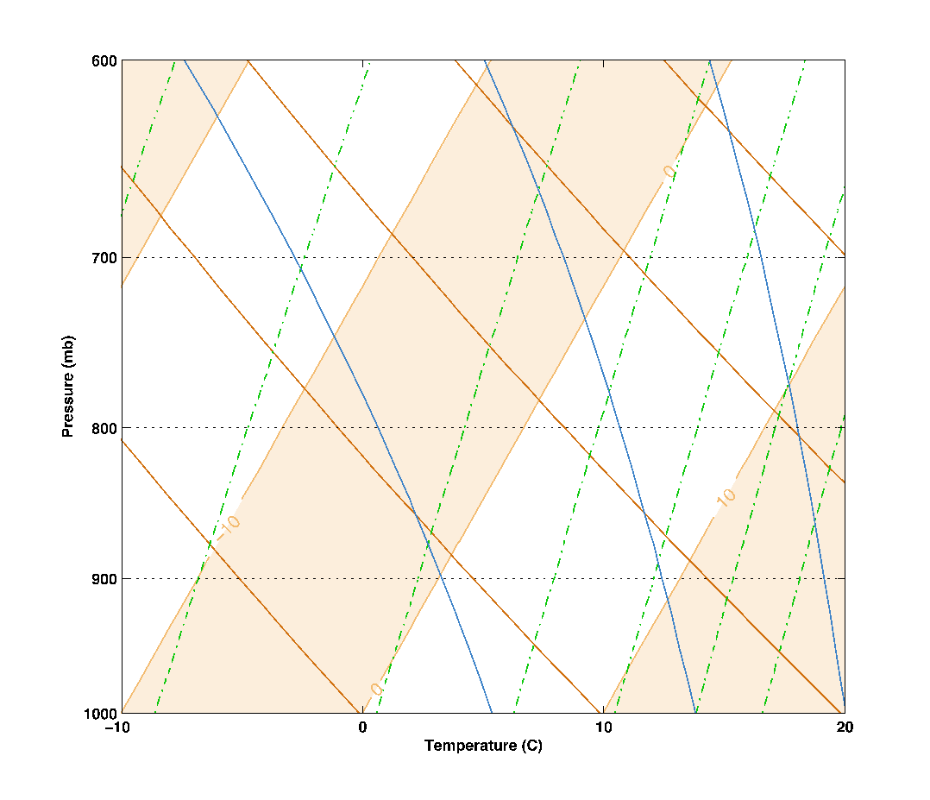
USE FIGURE 3 BELOW FOR #1-5

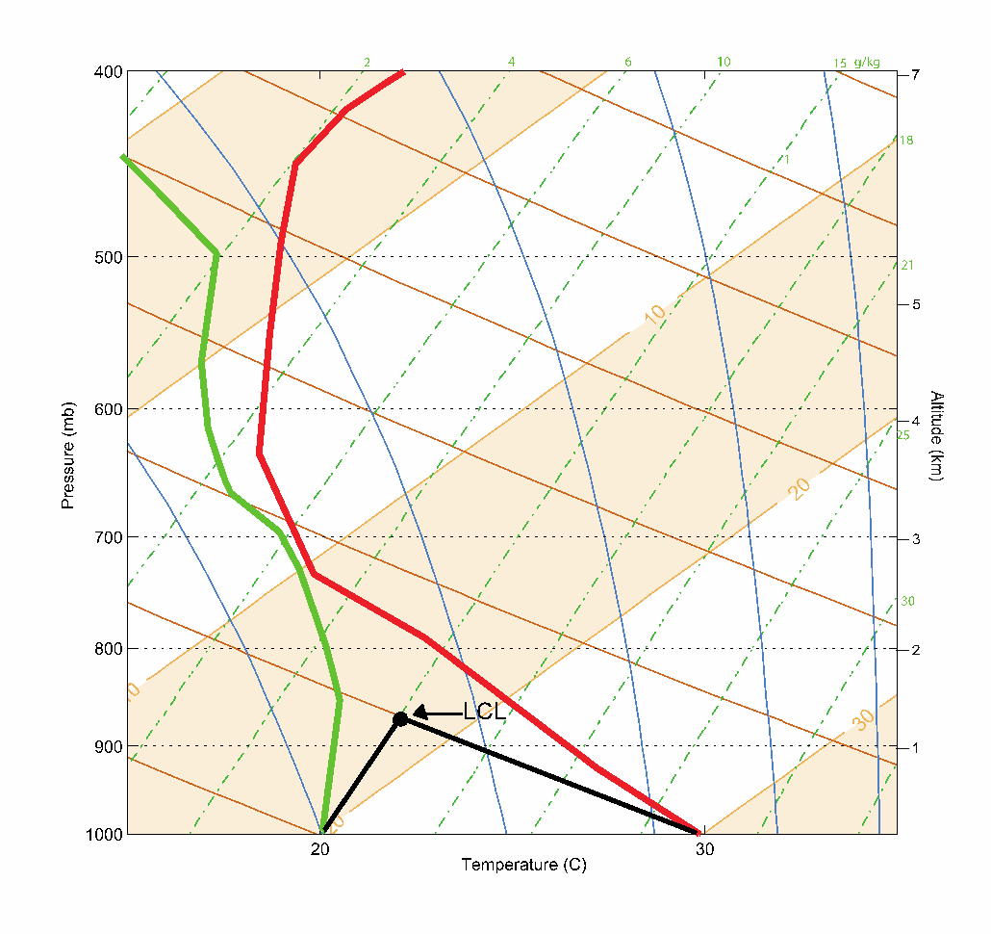
Figure 3:

For Questions 1-5, you are using Figure 3 (ABOVE) (it’s colored here!)

Question 1:
Remember temperature is the slanted line the goes to the right as you go up in altitude. Your green curve is the dew point and the red curve is the environmental temperature. If your temperature value at 800 mb is greater than 20 degrees Celsius, then your answer is not correct.

Question 2:
You have to reference the mixing ratio lines for this question (green dashed line). See slide 7 of the PowerPoint.

Question 3:
You have to reference the mixing ratio lines for this question (green dashed line). See slide 8 of the PowerPoint.

Question 4:
Round to the nearest tenth. See slide 9 of the PowerPoint.

Question 5:
Name just one type of weather condition when we would we care about all three of these measurements (relative humidity, mixing ratio, and saturated mixing ratio). I.E. when do we care about moisture?

Question 6:
For this question, use a pencil or erasable writing utensil on Figure 5 on page 38. You must show all four of your calculations in the space next to this question. Correct answers with no work, will not receive full credit. For the third part, it should read -30 degrees Celsius, not 30 degrees Celsius. Be sure that you are putting HEIGHT in the denominator and not pressure. See slide 16!
When you are doing this, you might not always be exactly ON the wet adiabatic line. In those cases, you have to run parallel to it.

Question 7:
There are three parts to this question:
- In general, how does the moist adiabatic lapse rate (MALR)compare to the dry adiabatic lapse rate (DALR). Is MALR<,>, or =DALR?
- How does MALR depend on temperature? As temp increases does MALR increase or decrease or stay the same?
- How does MALR depend on pressure? As pressure increases does MALR increase or decrease or stay the same?

Question 8:
You will use Figure 5 on page 38, to assess how saturated air will behave when lifted by a mountain (visual in figure 2 on page 35). Starting at 1000mb and 20 degrees Celsius you are going to lift the parcel following the moist adiabatic lapse rate (slide 6) until 800 mb is reached. Write down this temperature. Now you are going to assume that all of the moisture was condensed and rained out so now your parcel is dry. Follow the dry adiabatic lapse rate (slide 5) back down to 1000 mb. Write down this temperature.

Question 9:
You are using Figure 6 (pg 39), not Figure 5. Answer this in terms of pressure. See an example above in figure 3 (page 36 of lab manual). If you are still confused, I recommend re-reading the bottom of page 35 and slide 11.

Question 10:
You are basically reiterating how to do this AND what it means conceptually when you find the LCL (but you have to do this in your own words). See an example above in figure 3 (page 36 of lab manual). If you are still confused, I recommend re-reading the bottom of page 35 and slide 11.

Question 11:
You are still using figure 6. What is the temperature of the parcel lifted dry adiabatically from the surface to the LCL? Write this down. What is the environmental temperature (not dew point) at this pressure level? Write this down. How do these values compare? Does the air parcel have negative, positive, or neutral buoyancy? Will the parcel rise up or sink?

Figure 4:

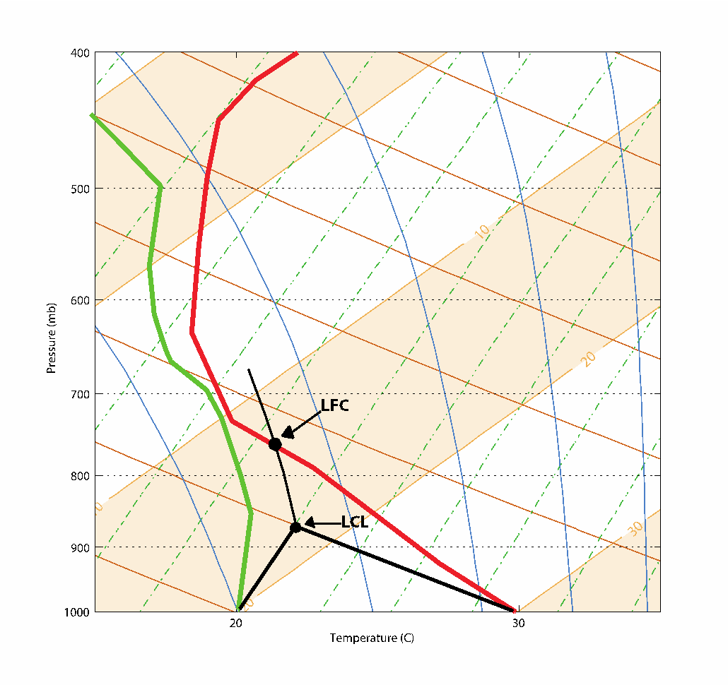

Question 12:
From the LCL follow the moist adiabatic up (or parallel to it) until you intersect with the environmental temperature line. See figure 4 above for an example. This is your LFC. Write down the pressure.
Question 13:
If you are struggling with this question you may want to re-read the bottom of page 36.

Question 14:
Continue following the moist adiabatic line past the LFC until it intersects with the environmental temperature line again. See slide 12 of the PowerPoint. This is your EL. Write down the pressure. What happens if the cloud is pushed past this pressure.

Question 15:
Do not use today’s most recent sounding. Use the one I have provided for you below. Mark your LCL, EL, and LFC as dots with a clear label on the graph. The important features I want you to find are:
- Where are there temperature inversions? (Hint: There is only two: a radiative inversion and a tropopause inversion) Always report inversions as a pressure range. (Slides 13-15)
- How much water vapor is in the air at 800mb? (Slide 7)
- What is the saturation mixing ratio at 800mb? And Relative Humidity % at 800 mb? (Slide 8-9)
- What could force a cloud to rise above the Lifting Condensation Level (LCL) (Slide 10)

Pressure (mb) | Temp (°C) | Dew Point (°C)
1000 | 15 | 4
900 | 18 | 1
800 | 4 | -7
700 | -2 | -18
600 | -13 | -32
500 | -30 | -34
400 | -37 | -39
300 | -48 | -53
200 | -58 | -65
100 | -60 | -82

Figure 5: Questions 6,8,15
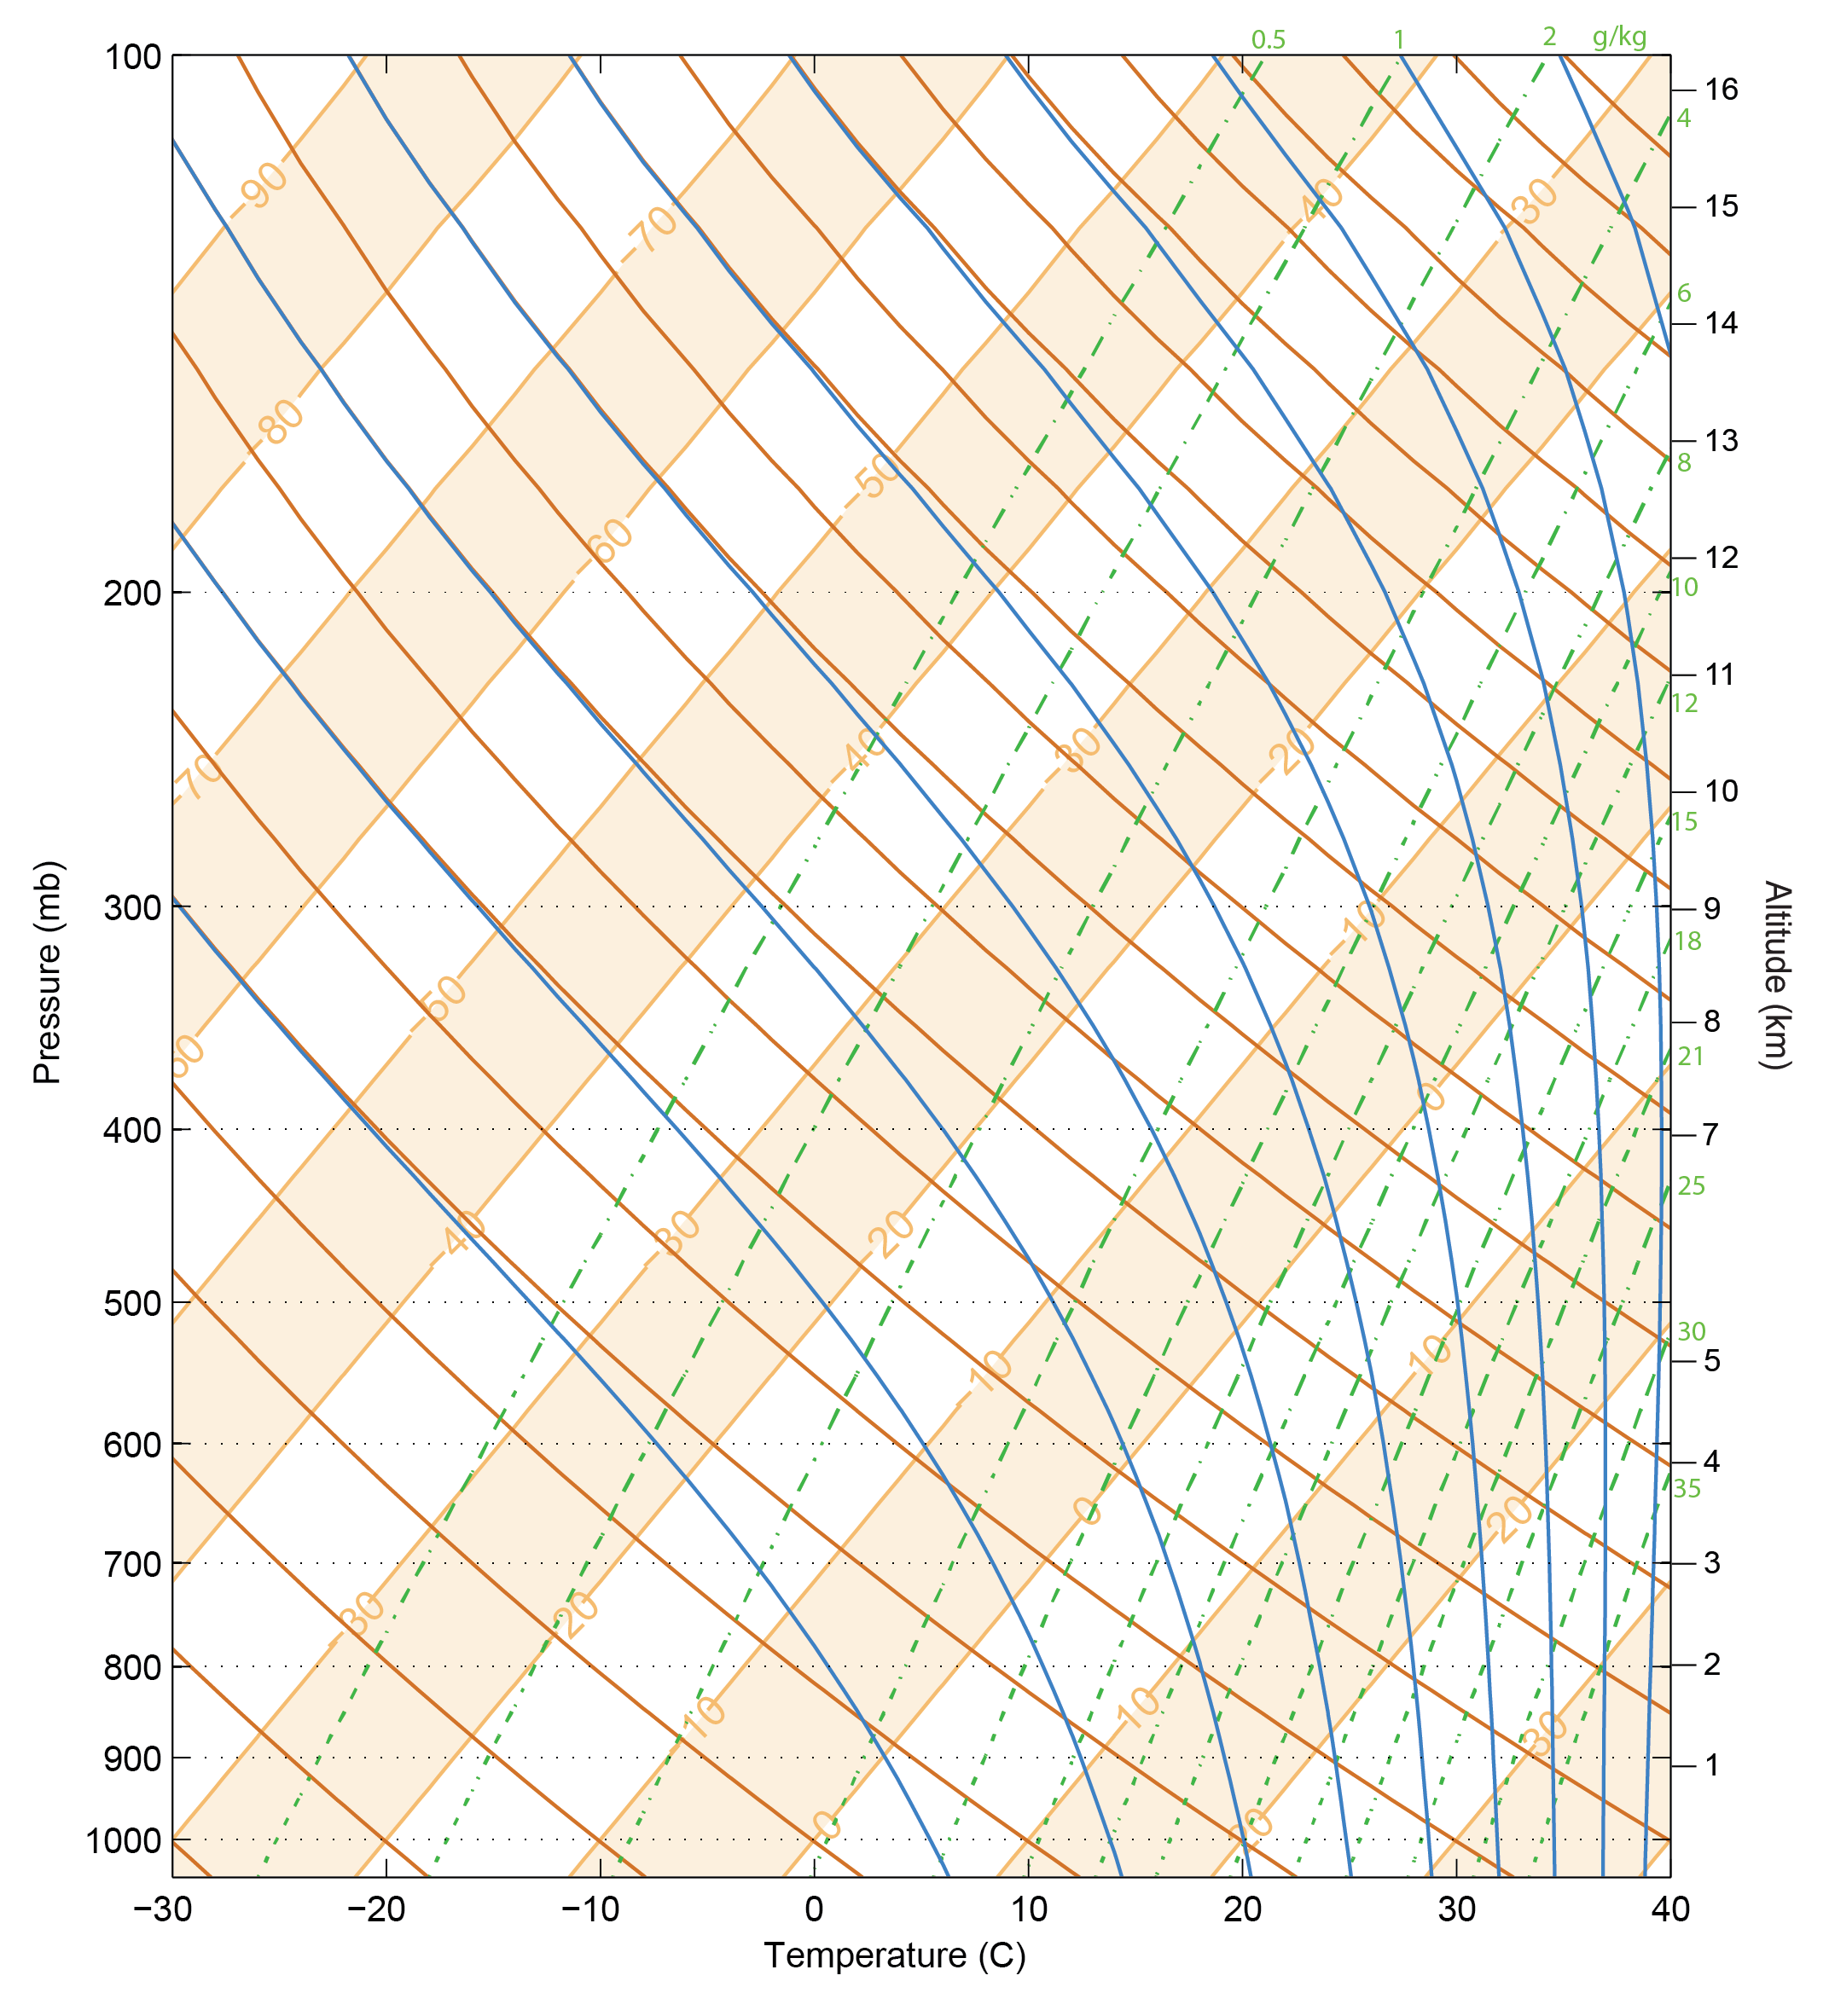

Figure 6: For questions 9,11,12, and 14
