Lab 5: Atmospheric Soundings

Background:
You MUST read the background very carefully in this lab. Please consult this document for the colored versions of the figures because they will be easier to understand than the black and white versions in the manual.
Also, there is a typo in the “Temperature” paragraph on page 26. It should say 400 mb instead of 500 mb (3rd paragraph)

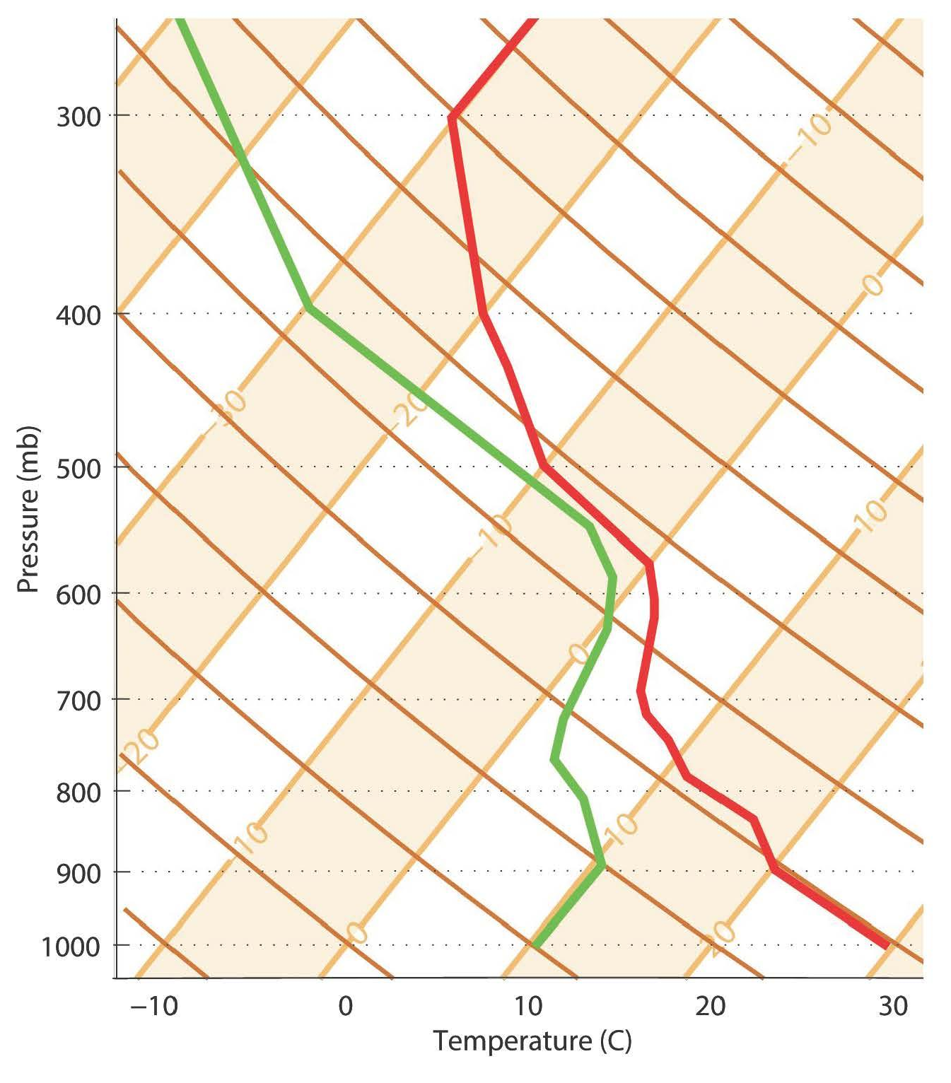
Figure 1

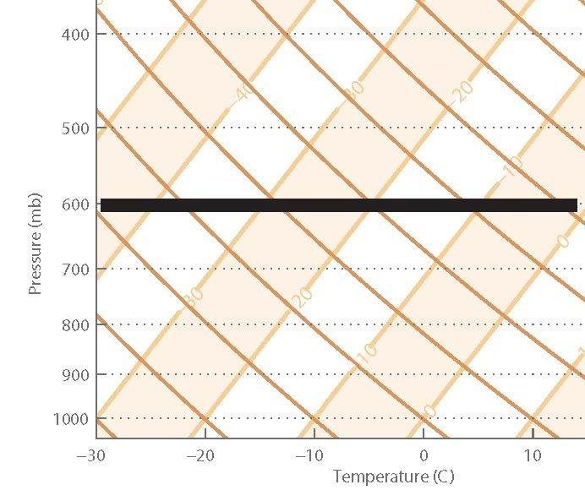

Figure 2

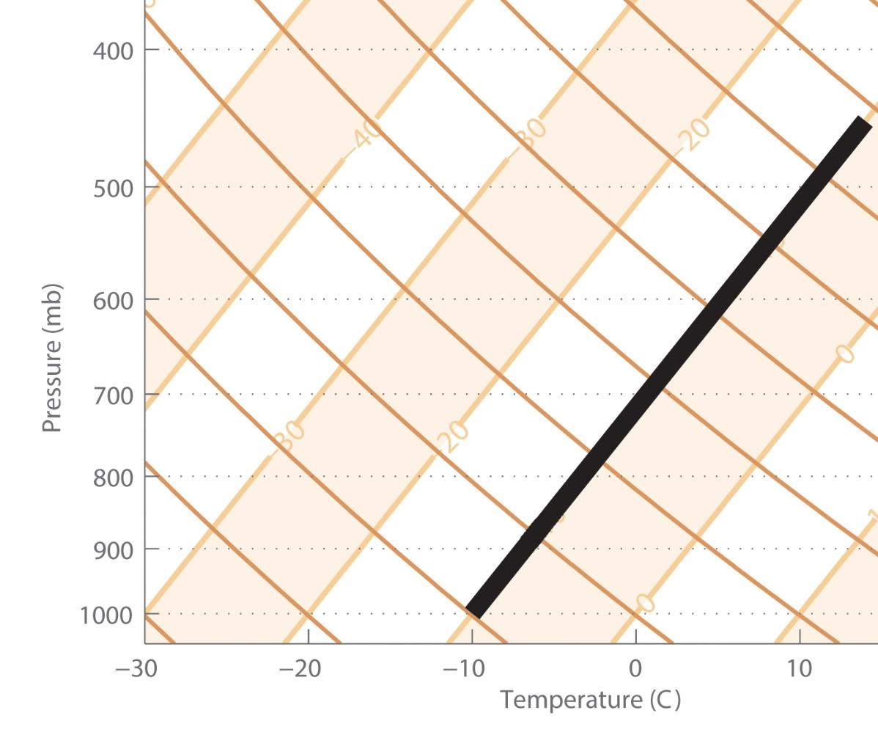

Figure 3
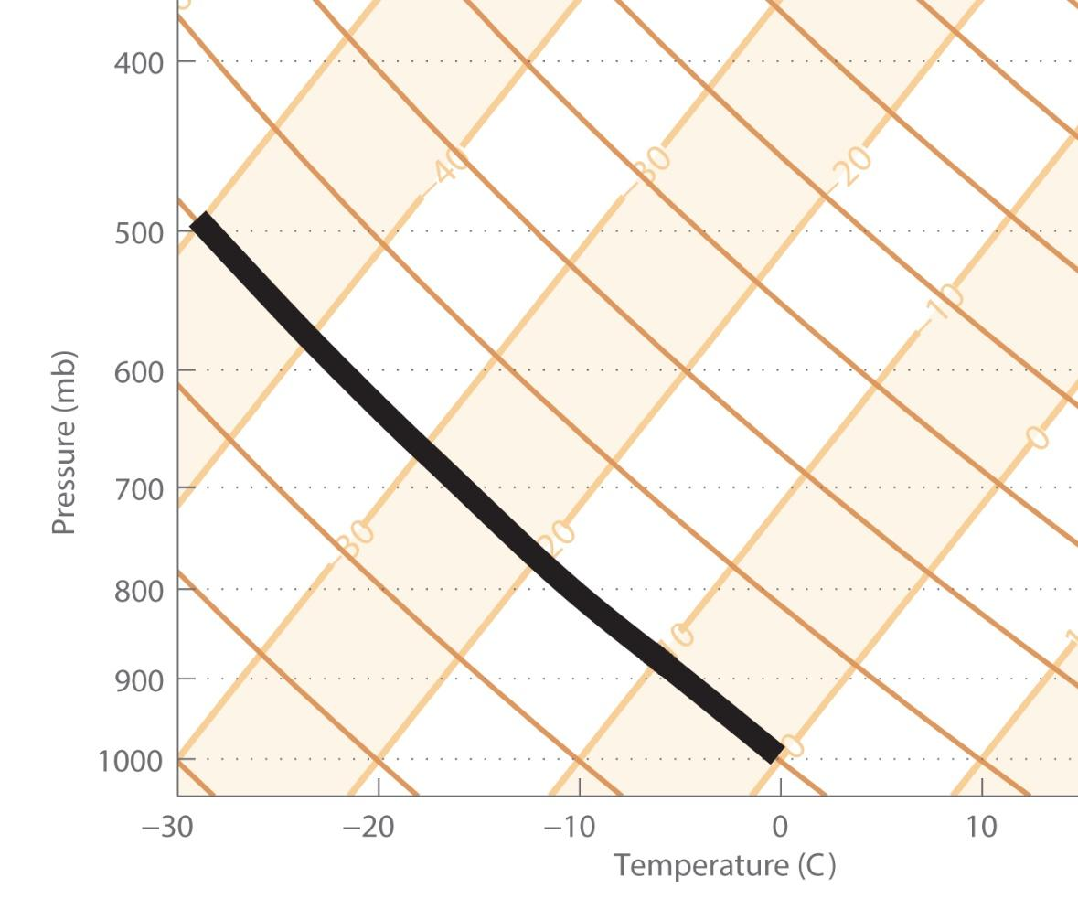
Figure 4

Question 1:
Use Figure 1 on the bottom of page 26. The line plotting the dew point is green (always on the left) and the line plotting the environmental temperature in red (always to the right of the green line). Complete the chart by finding the environmental temperature and dew point at 1000, 800 and 400 mb. If you get ~12 degrees Celsius for the Dew Point at 800 mb, then you are reading the figure incorrectly. Remember the temperature lines run diagonally not straight up and down. DON’T FORGET UNITS!
Question 2:
The data is given on page 29. You are going to plot the data on page 31. Connect the dots with straight lines. Remember the temperature lines run diagonally not straight up and down. Make sure to draw the dew point (on the left) green and the environmental temperature (right) red.

Question 3:
Tell me the pressure at the two moistest places and two driest places. It helps to create a third column on table 1 (page 29) to calculate the differences between Temp and Dew Point. If the points are very close (small difference), what does that tell you about moisture? (Hint: Slide 6 of the PPT) Remember to name the pressure of two of each, dry and most, places. DON’T FORGET UNITS!

Question 4:
How does this relate to question 3? Pick the pressure (just pick one) most likely to have clouds formed. You are looking for a moist place (pressure) closer to the Earth’s surface that has a temperature inversion.

Question 5:
The lapse rate is the slope in which temperature changes with height. The atmosphere is most stable where you have the largest lapse rate. Remember that temperature inversions occur when the lapse rate is greater than zero. For this question you are looking for the pressure range when the environmental temperature has the strongest temperature inversion, because less vertical motion will occur. This is a range, not just a single pressure.

Question 6:
There are three of these: nocturnal/radiative (closest to the ground; fog), capping (second closest to the ground; clouds forming), and tropopause (furthest from the ground). The tropopause is considered a temperature inversion because temperature remains roughly constant. It may be helpful to look on table 1 (page 29) for a pressure change in the upper atmosphere where temperature only changes a small amount. Provide the pressure range for each.

Question 7:
You may use the reference Skew-T’s at the front. First find your starting point (remember Temperature is plotted on a diagonal line). For 7b. your starting point is where 10C and 800 mb intersect. You may want to mark this point with a dot. Now you are going to draw a line that intersects your point and is parallel to the dry- adiabatic lapse rate (the curved line described on slide 5). Now starting at your initial point (7b. is 10C, 800 mb) follow the line you drew parallel to the dry-adiabatic lapse right up or down to the final pressure you are looking for in the question (7b. your final pressure is 500 mb). Make a point at this new pressure. Now from this second point you will find the temperature at this point and record it for your answer.

Question 8:
Hint: reread the background to determine how temperature acts when it is well-mixed (before the boundary layer). I want you to record the height OR pressure at the top of the boundary layer. If you get a number <700 mb then your number is too low.

Question 9:
- Use Table 1, for this. The surface is 1000 mb.
- Using the point in a you are going to find the temperature if the parcel is lifted to 700mb. Do the same thing you did in #7.
- Use Table 1, for this. What is the environmental temperature at 700 mb.
- Slide 12 might be helpful.

Question 10:
Big Hint: To find how high it will rise start at 30 degrees Celsius and 1000mbar and follow up a dry adiabat until you intersect with your temperature line (red). When you read “subsidence inversion” think sinking air, so when air is unable to rise.

Question 11:
I found the data for you. It is from Dulles Airport yesterday at about noon
Answer the following based on the sounding below:
You should be looking at the Temperature line(red). Temperature is always greater than or equal to the dew point.

- Any inversions you see, including the range of pressures at which they are present. There is no nocturnal inversions but there are two obvious inversion between 900 and 750mb. List the range of pressure for each of these Inversions
- Where is the top of the troposphere?
- Was that atmosphere moist yesterday? Does that agree with your experiences on campus yesterday?
PLEASE REMOVE PAPER FRILLS. PUSH IN YOUR CHAIR AND LOGOFF THE COMPUTER. THANK YOU!

