Lab 12: Climate

Introduction:
For equation (1), there is a typo for the value of sigma. It should be: σ = 5.67 x 10⁻⁸ W m⁻² K⁻⁴ . There is also a typo for E: it should read E=σAT⁴. The letters with exponents are units!

For equation (2), R_{e} is the radius of the earth and it is the same thing as just plain old R. This is important to understand for number 1.

Question 1:
Your final answer should have fewer terms than what you started with because of cancellation.

Question 3:
BEFORE you answer this question, you must find a new equation to use. Read the paragraph immediately above question 3 but cross out and ignore the first sentence. At the end of the paragraph, insert this sentence:

“The planetary temperature that accounts for albedo is called the effective temperature,
and it is the temperature that a planet would have if there were no atmosphere surrounding it. The actual temperature accounts for both albedo and the atmosphere.”

Take the equation you found in question 2, but then fix the equation to give you effective temperature based on the information you read in the paragraph. Think about what happens when we have albedo: are we letting all of the incoming solar radiation be absorbed? Albedo is denoted by the Greek letter α (alpha).

The units of temperature are Kelvin (K).

Question 5:
Think of the question this way: Why is Venus’s actual temperature so high and why, when we take away the atmosphere, is the difference between its actual temperature and effective temperature so large in comparison to the difference for other planets? Answering both of these questions will earn you full credit on this question.

Question 7:
For equation (4), W/m² is a unit. There is a typo in the definition of pre-industrial concentration of CO₂ (~280 ppm). This should be c₀, while c is the current concentration of CO₂.

To find the current CO2 concentration, go to this site: https://www.co2.earth/

Website for part b is http://cdiac.esd.ornl.gov/pns/current_ghg.html

Question 8:
Use the same website that you used for number 7 part b. When you get to CFCs, the value you should write down is the sum of ALL of the chemicals under that very last subcategory on the website called “concentrations in part per trillion,” even though some of them are halons.

Question 9:
You don’t have to show your work for this question, but if you don’t add up all of the correct values (don’t forget any!) it will mess up your answers for the rest of the lab.

Question 10:
W m⁻² K⁻¹ are units for Plancks feedback parameter. ΔF is your value from #9.

Question 11:
Look at the graph on the next page. This represents the actual/observed temperature that will be referenced later on in the lab. For calculating the rise in temperature from this, observe how the data appears as vertical lines spiking up and down. Now look at what you think is the very first one of those lines and find a point smack dab in the middle (this is an average value for the beginning of the data) and do the same thing for the very last line (average for the end of the data). Find the difference between these two values to calculate the rise in temperature. Your value should not be greater than 1֯C.

Question 12:

I will display an image of the Clausius-Clapeyron curve for you to referance as a hint.

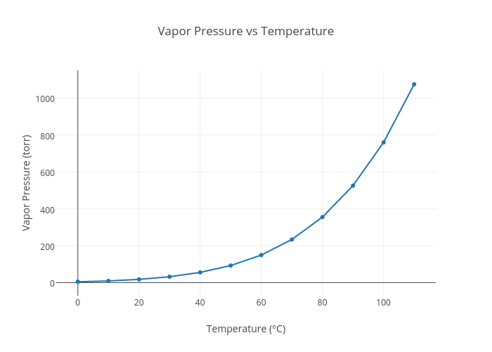

Question 13:
Example: “A rise in [variable 1] leads to a [rise/fall] in [variable 2] which in turn leads to a [rise/fall] in [variable 1], which [perpetuates/kills] the system.”
Replace variables with temperature and water vapor, and select rise, fall, kill, or perpetuate.

Question 14:
You are using the equation at the bottom of the previous page and doing this calculation twice to produce two numbers. For the first calculation, use $λ = 1.5 Wm^{-2}K^{-1}$. The second time, use $λ = 2.5 Wm^{-2}K^{-1}$. Remember that λ_{p} is Plank’s feedback parameter given to you on page 84 ($λ_{p}=3.2 Wm^{-2}K^{-1}$). You answer represents the possible range in temperature rise based on our two possible feedback parameters. “Consider climate feedback, temperature is predicted to rise ____ to _____ K since pre-industrial time”

Question 15:
I am looking for two specific things here. Reread how the study found estimated the climate feedback parameters. What did they not include? How will these two things not included impact temperature rise? Let your answer for #11 be the actual/observed temperature rise.

Question 16:
Subtract 1 from your radiative forcing value (#9) and do the calculations that account for climate feedback again. You must then tell me how this compares to the answer you got for number 14, why it is different, and how this compares to the observed temperature change (#11).

Question 17:
Take the radiative forcing value you used in number 16 (#9 minus 1) and fix it to account for 30% going into the ocean. If 30% is going into the ocean, what does that mean for the amount absorbed by the atmosphere? Then do the calculations that account for climate feedback again. You must then tell me how this compares to your answer for number 16, why it is different, and how this compares to the observed temperature range (#11).

